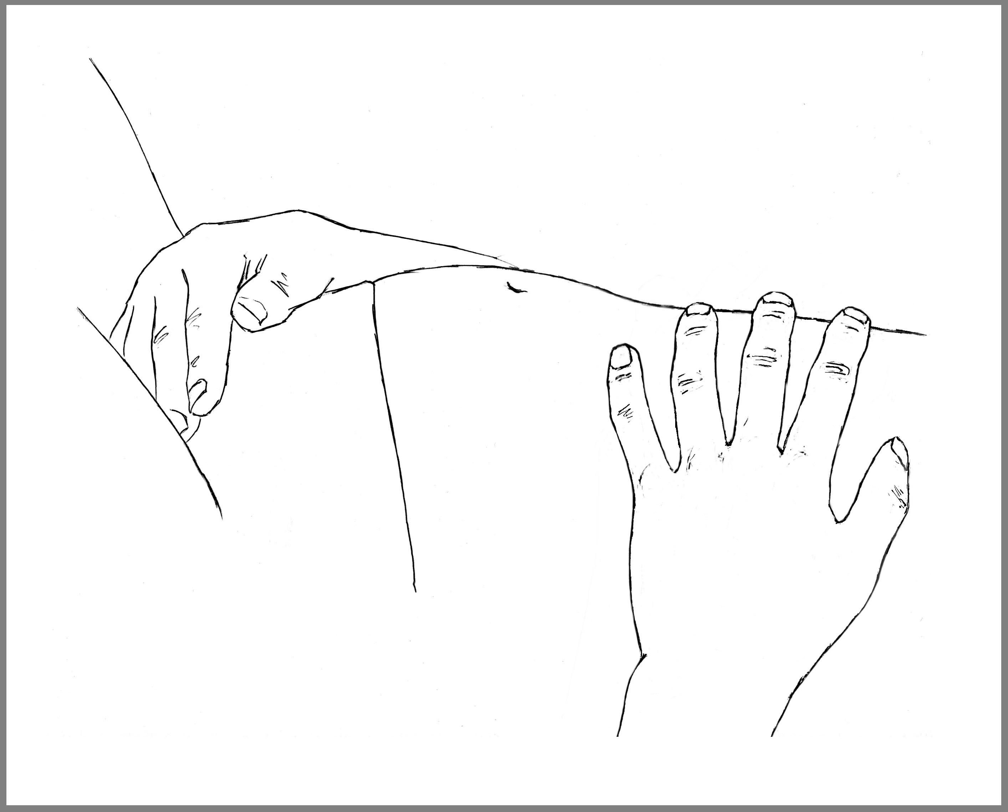
DO
SNIFF in through the nose

FLOP, swell or fill out your soft stomach

DROP, release or open at the back passage -backwards

Do all three (Sniff Flop & Drop) at exactly the same time
Try to feel that the sniff-in connects with the pelvic floor to LET GO
The less effort the better the connection will be – don’t force it
Stay on the in-breath for 3 seconds keeping the stomach soft
Exhale with a soft ‘hah’ as if cleaning your glasses
Keep doing this for 5-10 minutes lying on your back with your knees bent or lying on your side

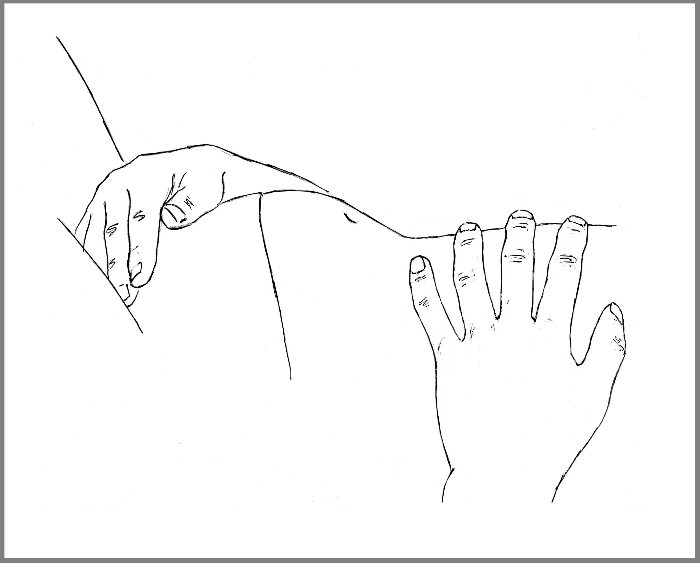
DON’T:
DON’T brace, hold or force your upper abdomen
DON’T push down with the ribs
DON’T try too hard
DON’T lift your chest

THE STOMACH SHOULD NEVER BE TENSE AS YOU BREATHE IN !

