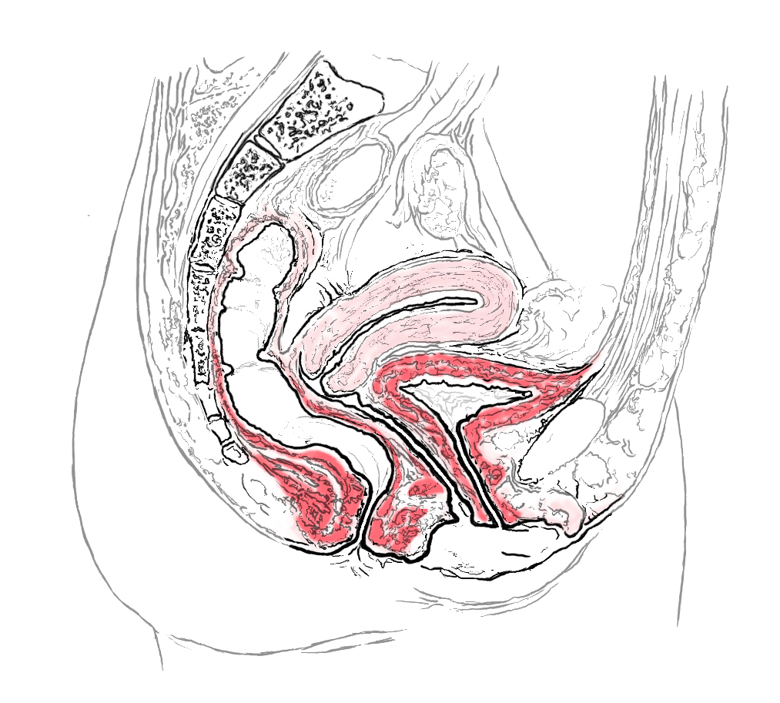
Before you start contracting the pelvic floor you must make sure it is first completely relaxed. Look at the diagram here and see the difference between relaxed and contracted below

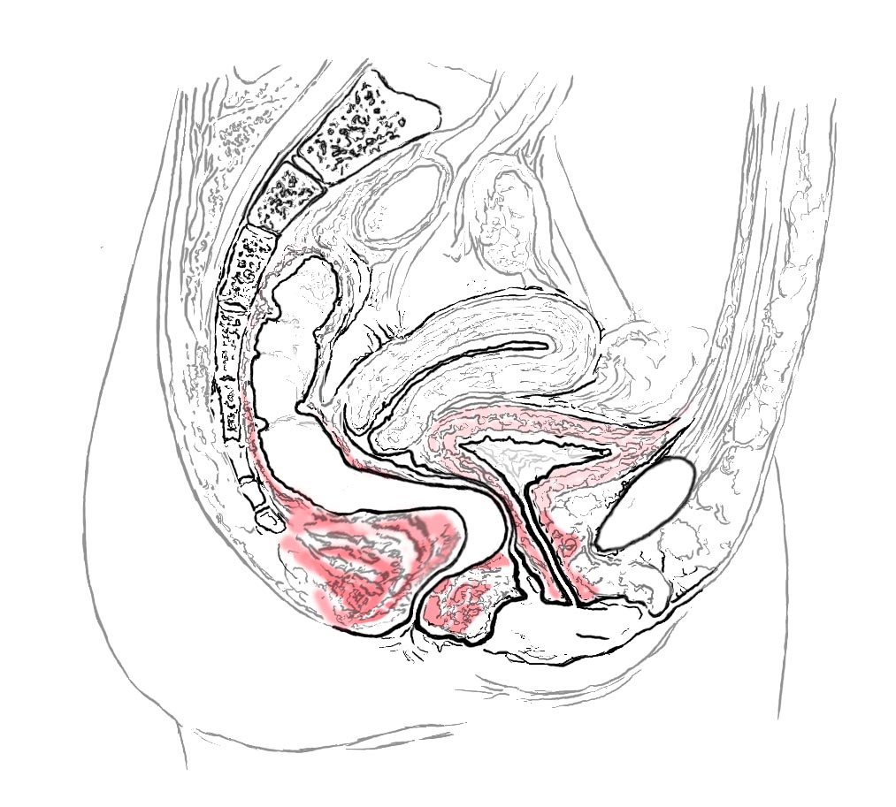
Breathe (sigh) out before you start making sure that your lungs are completely empty

Squeeze the pelvic floor in isolation, think of the back passage coming in from the back up and forwards towards the front to the bladder
Make sure you don’t lift your chest

Keep holding this for 5 seconds
Drop it back completely

Finish then with Sniff Flop & Drop

Repeat this 10 times after you have finished 5 mins Sniff Flop & Drop lying down once / day

PLUS 2 more sets of 10 reps on the go i.e. sitting / standing over the course of the day

This is a starting dose and will need to be progressed in accordance with the principles of pelvic floor exercise training

